Final Written Report

BC2406: Analytics I: Visual & Predictive Techniques

Satya Nikitha Pulapa | U2411880A
Sean Kho | U2440286G
Kuwabara Tsusha | U2140442B
Liew Jun Hao | U2420224G
Sahoo Sidharth Sankar | U2421501K
Dhruv Punjabi | U2411242G

Executive Summary 3
1. Business Understanding 4
1.1 Introduction 4
1.2 Background 4
1.3 Problem Statement 5
2. Data Exploration 5
2.1 Data Structure 5
2.2 Univariate Analysis 6
2.3 Bivariate and Multivariate Analysis 7
2.4 Evaluation of Dataset 8
3.Data Cleaning & Preparation 8
3.1 Missing Values 9
3.2 Duplicate Values 9
3.3 Outliers 9
3.4 Data Transformation 9
4. Data Modelling and Evaluation 9
4.1 Logistic Regression Model 9
4.1.1 Results from Logistic Regression Model 10
4.1.2 Evaluation of Logistic Regression Model 10
4.2 Decision Trees (CART) 11
4.2.1 Results from CART Model 11
4.2.2 Evaluation of CART Model 12
4.3 Random Forest 13
4.3.1 Results from Random Forest Model 13
4.3.2 Evaluation of Random Forest Model 14
4.4 Model Comparisons 14
4.5 Clustering 15
4.5.1 Results from Clustering Model 15
4.5.2 Evaluation of Clustering Model 16
5. Implications 17
5.1 Model Deployment in Healthcare Setting 17
5.2 Current State Assessment: Strengths & Acknowledged Limitations 18
5.3 Proposed Research Validation Roadmap: Three Phase Approach (20 Months) 18
5.4 Conclusion 21
Appendices 22
Appendix A: Summary of Dataset 22
Appendix B: GVIF Values of Variables 22
Appendix C: Complexity Parameter for CART model 22
Appendix D: Feature Importance for Random Forest 23
References 24

Executive Summary
The project aimed to develop a predictive model using machine learning to identify individuals at high risk of developing diabetes from a dataset that contained 7,900 cleaned records. These records had various variables of medical and demographic nature that were then subjected to extensive exploration through univariate and multivariate analyses. In the univariate analysis, boxplots showed that diabetic patients were older, with higher measures for BMI and HbA1c levels. The bivariate analysis demonstrated further that blood glucose and HbA1c were more strongly related to diabetes risk than with hypertension and heart disease.

We applied different machine learning modeling approaches, namely Logistic Regression, CART (Classification and Regression Trees), Random Forest, and K-Means Clustering. The Logistic Regression model yielded an accuracy of 83.7%, but the false positive rate was relatively high at 17.2%, with a false negative rate of 15.3%. The key predictors in the model were age, BMI, and HbA1c. Removing non-significant variables, such as smoking history, led to minor improvements; however, the problem of false positives remained.

The accuracy of the CART model was 86.3%, with a reduced false positive rate of 11.6% but with a slightly higher false negative rate of 15.6%. HbA1c and blood glucose level were identified as the most critical predictors of diabetes by the decision tree approach. The model was easy to understand and yet had problems with false negatives, suggesting refinement should proceed.

The Random Forest model performed the best with an accuracy of 87.5%, a low false positive rate of 10.6%, and 14% for false negatives. Due to its robustness in capturing the complex, nonlinear relationships between important predictive features of BMI, HbA1c, and blood glucose, it stands out as the most reliable in predicting diabetes risk.

Lastly, the unsupervised learning method called K-Means Clustering identified two major groups based on age, BMI, HbA1c, and blood glucose levels. Although the clustering algorithm provided valuable insights into stratification of diabetes risk, it failed to offer predictive powers matched by the supervised models.

The Random Forest model was chosen for deployment in Healthier SG for early intervention and prevention. While the model performance was strong, further improvements are possible only through retraining and the addition of more diverse data. Potential limitations include data imbalance, bias in data, and how these could impact the performance of the models. Further work is required to handle the false negative cases. In conclusion, the predictive model from this project represents a leap in early diabetes detection, hence helping the preventive health policy in Singapore. Subject to further refinements, the model will help alleviate the national diabetes burden by identifying high-risk individuals and providing timely interventions.

1. Business Understanding

1.1 Introduction
Chronic diseases such as type 2 diabetes have become a significant public health issue in Singapore. In 2016, the Ministry of Health (MOH) launched the “War on Diabetes” initiative to show Singapore’s serious commitment to tackling the rise in diabetes cases and promoting a healthier population (Ministry of Health Singapore, 2022). As of 2022, over 400,000 Singaporeans were living with diabetes, and projections suggest this number could exceed 1 million by 2050 if trends persist (Ow Yong & Koe, 2021). In 2022, government spending on healthcare tripled from $3 billion to $10 billion over the past decade and is projected to increase further to $27 billion by 2030 if chronic disease rates continue to rise (Ministry of Health Singapore, 2022).
Launched in July 2023, a key aim of the Healthier SG initiative is to transition Singapore's healthcare system from a treatment-based approach to one focused on preventive care. Healthier SG aims to address the root causes of chronic diseases, including diabetes, by promoting healthier lifestyles, encouraging preventive screenings, and offering early intervention for individuals at risk. As part of this initiative, individuals can enrol with a primary care physician and adopt a personalised health plan, which includes regular screenings, vaccinations, and lifestyle adjustments (Ministry of Health Singapore, 2023).

1.2 Background
Optimizing diabetes screening and intervention has become an urgent need in Singapore's healthcare system. Although several tools, such as the Diabetes Risk Assessment (DRA), exist and serve as very useful starting points, their use is usually limited by generally low predictive power, with reliance on self-reported data and basic risk factors (Ministry of Health Singapore, 2017). While the DRA tool has successfully identified a high-risk group, it does not capture the full spectrum of risk factors contributing to diabetes onset, including blood glucose level, physical activity, and diet (Ministry of Health Singapore, 2023).
Presently, the majority of people having pre-diabetes or early stages of undiagnosed diabetes are overlooked by these conventional techniques, thereby leading to missed opportunities for early intervention. As a result, a sizable group of people do not qualify for clinical intervention and thus have restricted access to preventive care (Smith et al., 2020). Furthermore, the present technique does not consider the many interactions between the various risk factors such as age, level of glucose, body mass index (BMI), genetic predisposition, lifestyle, and medical history (Ting et al., 2019).
Current population-level diabetes risk assessment tools are limited in their ability to accurately and promptly identify individuals at high risk of developing diabetes. This gap restricts healthcare providers from proactively targeting at-risk groups with timely interventions that could slow or prevent disease progression. To address this challenge, a data-driven predictive model can be developed to estimate an individual’s likelihood of developing diabetes, enabling earlier and more precise intervention. Such a tool would directly support the broader Healthier SG preventive care strategy and contribute to reducing Singapore’s national diabetes burden (Ow Yong & Koe, 2021; Ministry of Health Singapore, 2022).

1.3 Problem Statement
With a growing diabetes burden in Singapore, there is a need for a more precise yet accessible method to assess individual risk and support early intervention. Current assessment tools often lack the granularity required to detect risk early across diverse population groups. This project aims to show a proof-of-concept for a predictive model which helps clinicians identify patients at high risk of developing diabetes. The model will integrate clinical indicators (e.g., blood glucose, HbA1c), along with demographic and lifestyle-related factors, to capture risk nuances beyond traditional screening tools. By improving risk stratification accuracy, the model will support earlier and more targeted interventions, ultimately strengthening preventive care efforts.

2. Data Exploration
To develop and train the predictive model, we utilise the Diabetes Prediction dataset sourced from Kaggle. The dataset contains 100,000 patient records and includes both medical and demographic attributes relevant to diabetes risk assessment. Specifically, it comprises nine variables: gender, age, hypertension, heart disease, smoking history, body mass index (BMI), HbA1c level, blood glucose level, and diabetes status. These variables represent clinically recognised risk factors and lifestyle indicators associated with the development of diabetes. Their inclusion enables a comprehensive assessment of individual health profiles and supports the creation of a predictive model capable of identifying high-risk individuals more accurately. A summary of the dataset is under Appendix A.

2.1 Data Structure
The table below shows an overview of the variables in the dataset. The target variable, diabetes is a categorical variable with 2 levels: 0 and 1. Gender, hypertension, heart disease and smoking history are categorical variables while age, BMI, HbA1c level and blood glucose level are numerical variables.

Table 1: Description of variables in dataset
Variables | Description
Gender | Consists of “Male”, “Female” and “Other”
Age | Numerical variables indicating patient’s age
BMI | Numerical variables indicating patient’s body mass index
Hypertension, Heart disease, Diabetes | “0” represents patients without the disease,  “1” represents patients diagnosed with the disease
Smoking History | Classified into six categories:  - Current; Never; Not current; Former; Ever; No info  We decide to aggregate “not current”, “former” and “ever”. These three categories are combined into one category which is “past”. So then we only have “past”, “current” and “never”.
HbA1c, blood glucose level | Numerical variables of test for average blood sugar level over two to three months

2.2 Univariate Analysis
The target variable is plotted against each independent variable of interest (i.e. age, BMI, HbA1c) to produce a series of boxplots shown in Figure 1.

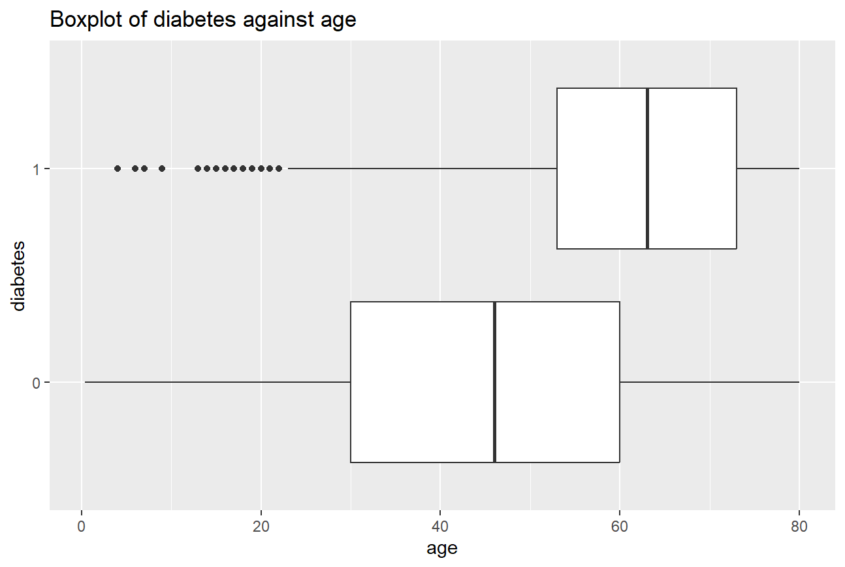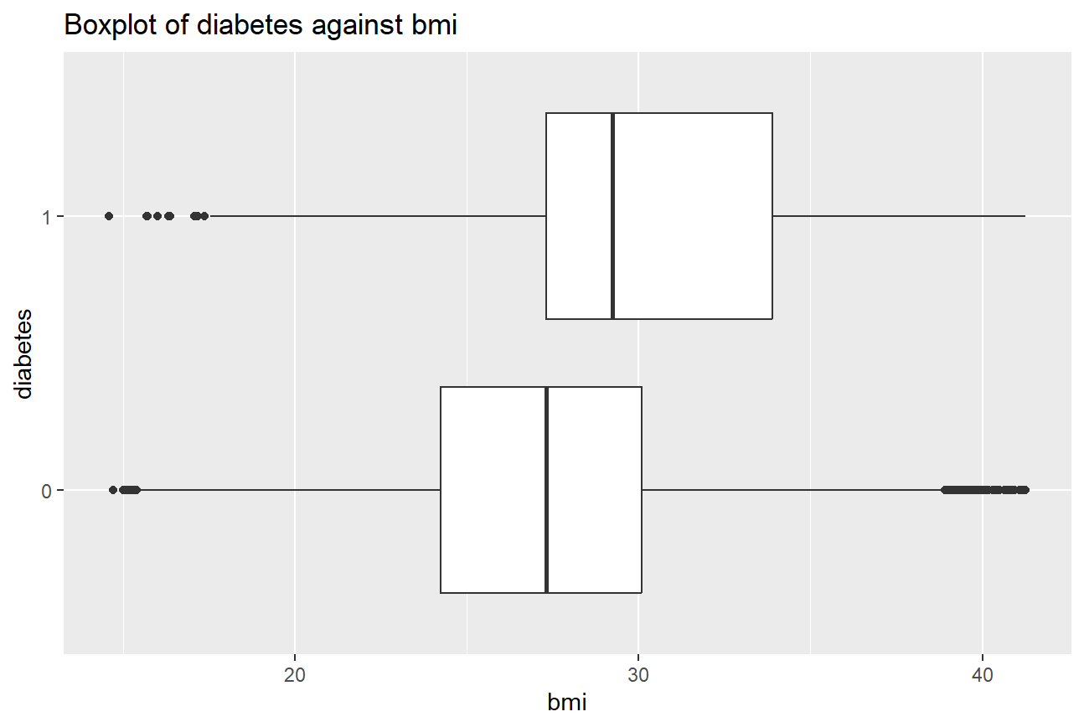
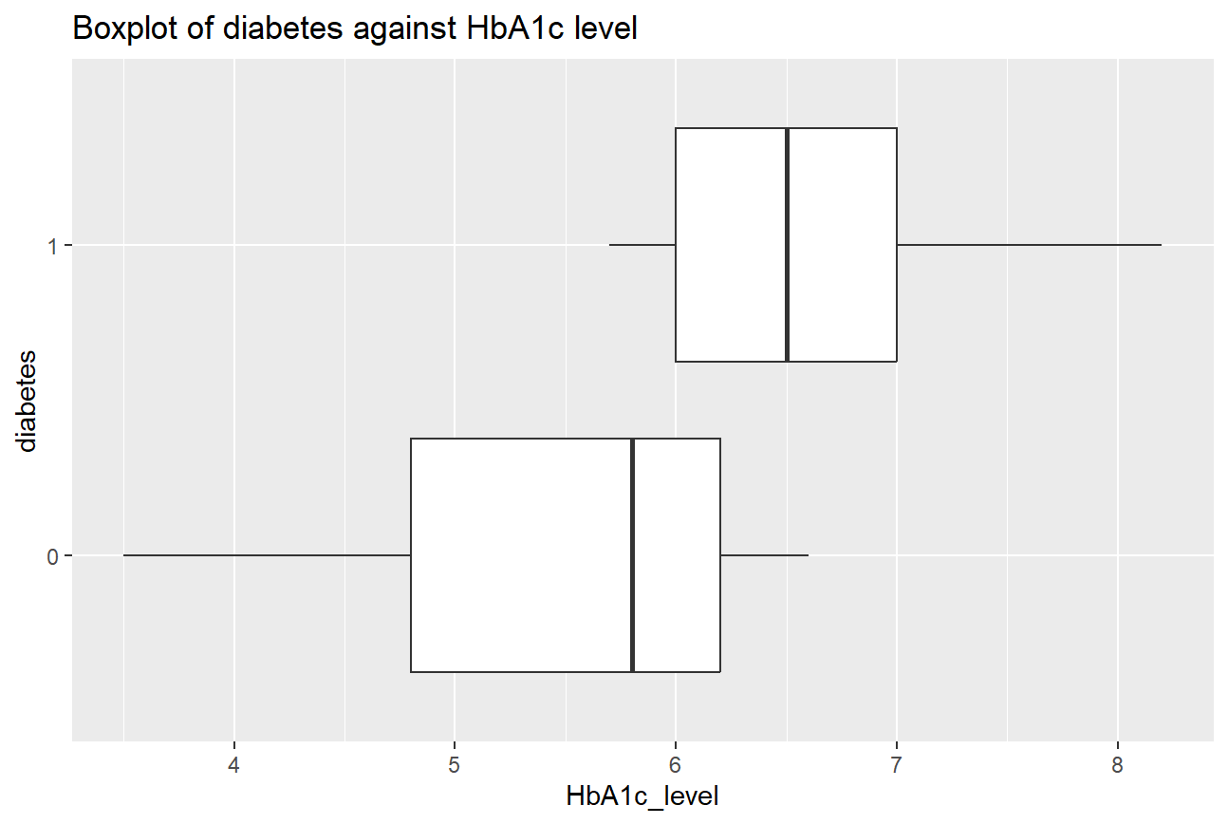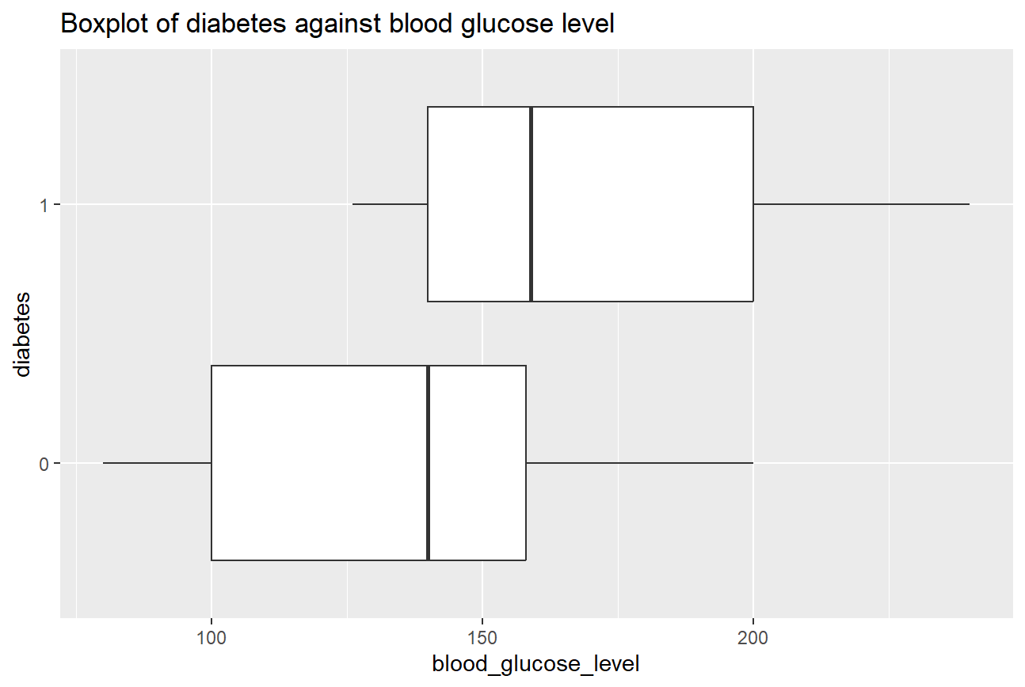
Figure 1: Boxplots of diabetes against age (top left), against BMI (top right), against HbA1c level (bottom left), against glucose level (bottom right)

From Figure 1 (top left), the median age of patients diagnosed with diabetes is observed to be higher than patients without diabetes. This indicates that older individuals are more likely to have diabetes. The interquartile range (IQR)—the width of the box—for diabetic patients is also positioned at higher ages, roughly between 50 and 70 years old, while non-diabetic patients’ ages mostly range between 30 and 55 years. A few young individuals are also diabetic, but these are relatively rare and are considered outliers.

Similarly, the boxplot of BMI (top right) demonstrates a positive association between BMI and diabetes. The 25th percentile, median, 75th percentile values for the diabetic group are higher than the corresponding values for the non-diabetic group, suggesting that individuals with higher BMI are more likely to have diabetes. The diabetic group shows a left-skewed distribution due to several low-BMI outliers, indicating individuals with relatively low BMI still develop diabetes. Conversely, the non-diabetic group includes outliers with both lower and higher BMI values, meaning individuals with elevated BMI may not have diabetes as well.

For HbA1c level (bottom left) and blood glucose level (bottom right), the lower fence, 25th percentile, median, 75th percentile and upper fence of the diabetic group are higher than the non-diabetic group. These observed distributions are consistent with clinical expectations that higher HbA1c and blood glucose levels are strongly associated with diabetes diagnosis.

2.3 Bivariate and Multivariate Analysis
To evaluate the predictive relevance of key variables, bivariate and multivariate analyses were performed. These analyses explored the associations between diabetes status, health indicators (i.e HbA1c and blood glucose level) and medical conditions (i.e. hypertension and heart disease) to understand their combined impact on diabetes risk.

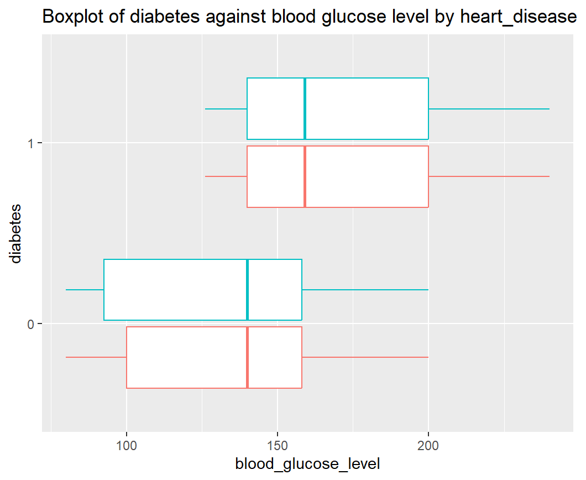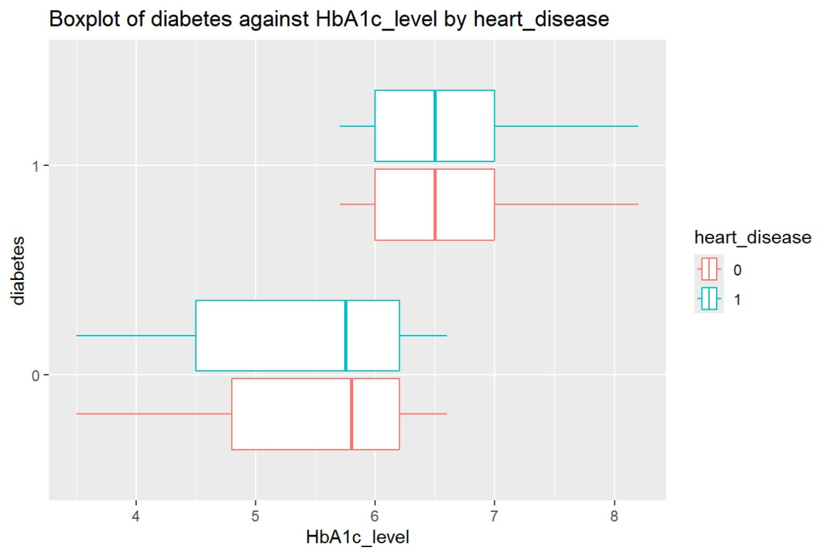

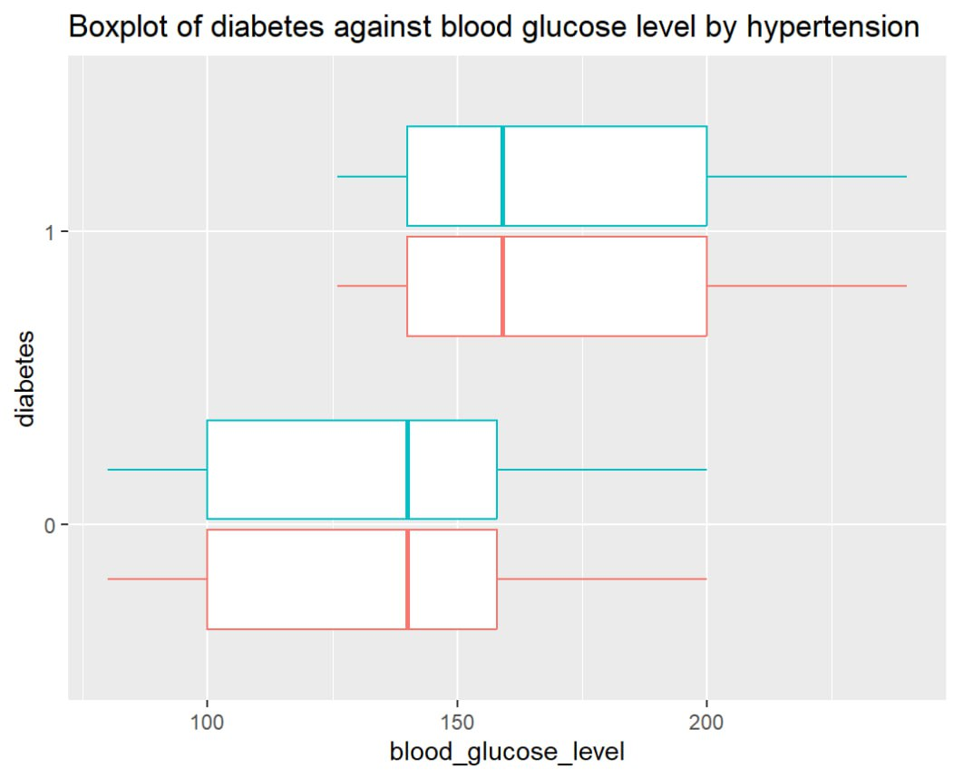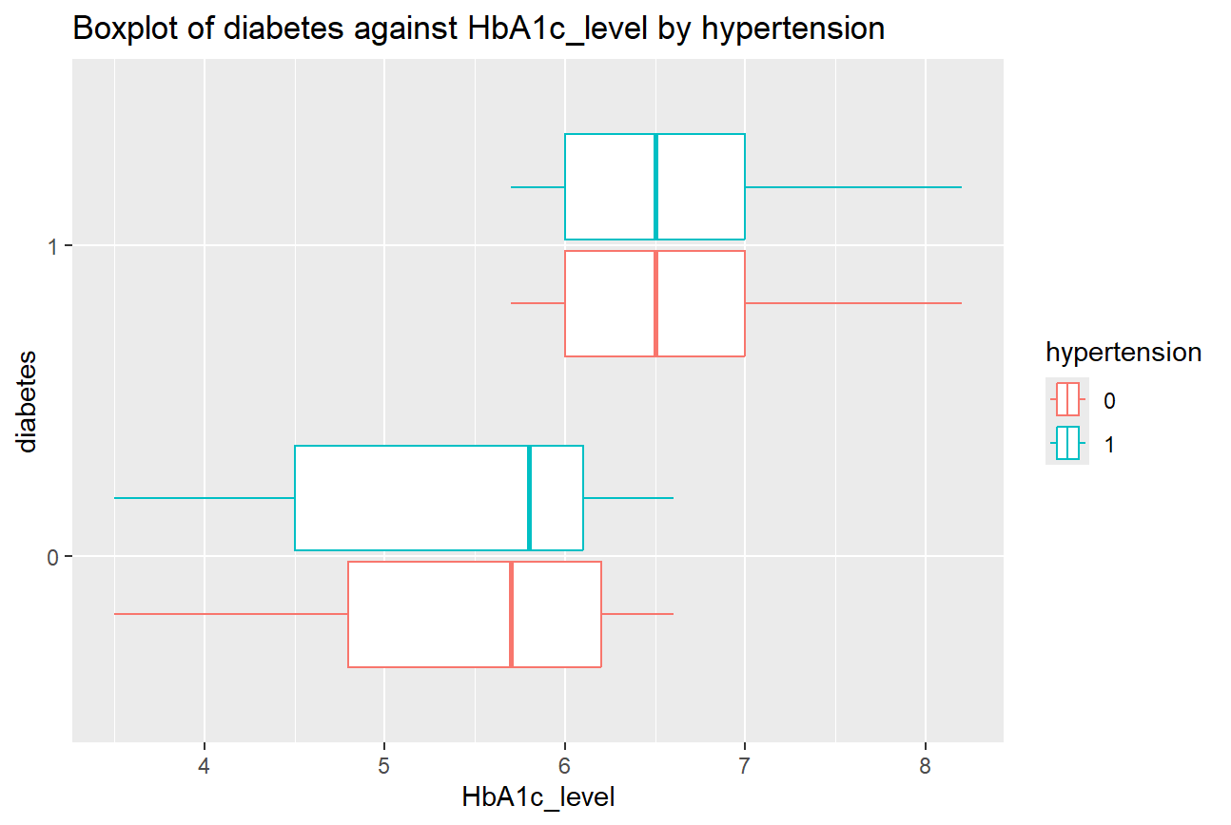
Figure 2: Boxplots of diabetes against BGL by heart disease (top left), against HbA1c level by heart disease (top right), against BGL by hypertension (bottom left), against HbA1c level by hypertension (bottom right)

Referring to Figure 2, the boxplots comparing diabetes status against blood glucose levels, grouped by heart disease, show that the lower fence, 25th percentile, median, 75th percentile, and upper fence values for diabetic patients are consistently higher than those for non-diabetic patients. However, blood glucose levels appear similar regardless of whether a patient has hypertension (bottom left), suggesting that hypertension does not strongly influence blood glucose variation in this dataset.
Similarly, when examining HbA1c levels grouped by heart disease, diabetic patients consistently exhibit higher values across all statistical measures compared to non-diabetic patients. Within the diabetic group, HbA1c levels do not vary notably based on hypertension status (bottom right). Among non-diabetic patients, the median HbA1c level is slightly lower for those without hypertension, while the 25th and 75th percentiles are lower for individuals with hypertension.
Overall, these patterns demonstrate that HbA1c and blood glucose levels exert a much stronger influence on diabetes status than other conditions such as hypertension.

2.4 Evaluation of Dataset
The exploratory visualisations reveal strong associations between several predictors and diabetes status, supporting the use of this dataset for our predictive model development.

3.Data Cleaning & Preparation
Data cleaning was conducted to improve the quality of the dataset, which directly impacts the reliability and accuracy of the predictive model. To mitigate potential issues, such as introducing bias, thorough steps were conducted to handle missing values, remove duplicate records, address outliers, and ensure balance in the target variable, diabetes.

3.1 Missing Values
No missing values found in the dataset. However, as mentioned in Table 1, there are patients without smoking records. Due to this data ambiguity, only patients with available smoking records were considered in our model. Entries with “no info” under the smoking history were therefore treated as not applicable and removed from the dataset.

3.2 Duplicate Values
After treating for missing values, the dataset was examined for duplicate records. Duplicate entries can indicate that the same patient was represented multiple times, which may compromise the accuracy of the predictive model. Duplicates were identified by checking for entries with identical values across all columns. A total of 1103 duplicate entries were identified. Given the dataset lacks a unique identifier to distinguish true duplicates from coincidental matches, all duplicate records were removed for consistency. The remaining dataset was sufficiently large for model development.

3.3 Outliers
Outliers were examined for each numerical variable. As shown in the boxplots in Section 2, outliers were detected in BMI, HbA1c, and blood glucose levels. For HbA1c and blood glucose, outliers were fully removed by excluding values outside the interquartile range. In the case of BMI, first-level filtering did not eliminate all outliers. Through the creation of additional boxplots, further analysis indicated that the remaining BMI values fell within a reasonable range and did not require additional filtering for model development.

3.4 Data Transformation
The resulting dataset was found to be highly imbalanced, with 53772 non-diabetic patients compared to 3974 diabetic patients. To address this imbalance, a random sample of 3974 non-diabetic patients was selected, creating a balanced dataset with an equal number of diabetic and non-diabetic cases. This sampling approach was chosen to maintain simplicity and interpretability, while ensuring the model is not biased towards the majority class. A summary of this sampled dataset is under Appendix A.

4. Data Modelling and Evaluation

4.1 Logistic Regression Model
Logistic regression is a statistical model that estimates the probability of a categorical outcome based on one or more predictor variables. It is particularly useful for binary outcomes such as diabetes diagnosis as it models the log-odds of an event occurring.

4.1.1 Results from Logistic Regression Model
In our dataset, the target variable, diabetes, is binary, and the observations are assumed to be independent. A key assumption of logistic regression is that the independent variables are not highly correlated (i.e. no multicollinearity). This was verified using the Generalised Variance Inflation Factor (GVIF), where a value close to 1 indicates no multicollinearity, while values approaching 5 suggest a strong correlation that could distort the model. All independent variables in the dataset exhibited GVIF values close to 1 (see Appendix B), satisfying the assumption of low multicollinearity.

A logistic regression model was then developed using a 70-30% train-test split to predict the likelihood of a person having diabetes based on the selected variables. The model results indicated that all variables, except for smoking history and the “Other” category of gender, have p-values below 0.001, demonstrating statistical significance. The coefficients of these variables were interpreted to assess their impact on the log-odds of diabetes. Following this analysis, variable smoking history was removed, and the model was re-evaluated for results comparison.

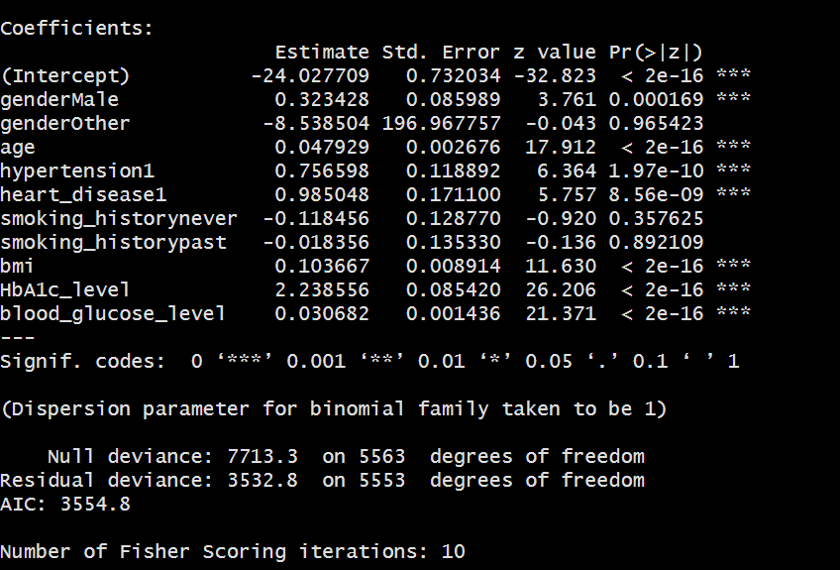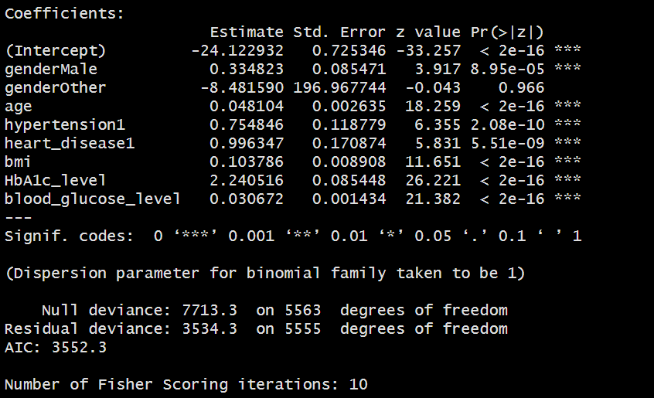
Figure 3: Logistic regression with all variables (left), Logistic regression after removing smoking history (right)

4.1.2 Evaluation of Logistic Regression Model
Though logistic regression lacks a straightforward visual output, the coefficients of significant variables allow for meaningful interpretation of each variable’s effect on the likelihood of diabetes.
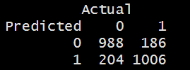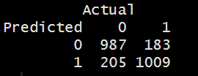
Figure 4: Confusion matrix of full model (left), confusion matrix of reduced model after removing smoking history (right)

Comparison between the full and reduced model revealed similar accuracies, with the reduced model performing slightly better. The accuracies of the model and the significance of each metric are illustrated below with a table.

Table 2: Model comparison between full and reduced logistic regression models
 | Full Model | Reduced Model | Significance of each metric
Overall Accuracy | 83.6% | 83.7%
False Positive Rate | 17.1% | 17.2% | Predicting that the person has diabetes when he does not
False Negative Rate | 15.6% | 15.3% | Predicting that the person does not have diabetes when he does
Key findings from the logistics regression model indicated several significant predictors of diabetes. Males have 1.40 times higher odds of developing diabetes compared to females. Individuals with hypertension or heart disease also exhibit increased odds of diabetes. Age is also positively associated with diabetes risk, with each additional year of age corresponding to a 4.9% increase in odds (i.e log-odds of 0.048) of developing diabetes. BMI is similarly significant, whereby a unit increase in BMI raises the odds of diabetes by 1.11 times. These preliminary findings suggest that healthcare providers should consider earlier and more frequent checkups for older individuals, particularly males, and closely monitor patients with higher BMI or relevant medical histories such as hypertension and heart disease.
Among clinical indicators, HbA1c is particularly influential. A 1% increase in HbA1c level corresponds to a 9.49-fold increase in odds (i.e. log-odds of 2.24). Blood glucose levels are also notable, with each 1mg/dL increase associated with 3.11% rise in odds. These findings align with current medical knowledge and underscore the importance of monitoring HbA1c and glucose levels to facilitate early detection and intervention for individuals at risk of developing diabetes.

4.2 Decision Trees (CART)
Classification and Regression Tree (CART) is a predictive modeling technique that estimates the outcome of a target variable based on input features. It employs a binary decision tree structure, which makes the model intuitive, easy to visualise, and straightforward to interpret. CART’s versatility allows it to handle both continuous and categorical dependent variables.

4.2.1 Results from CART Model
For our dataset, it is assumed that the observations are independent. The CART model was developed with a 70-30% train-test-split to predict a categorical outcome on whether a person has diabetes based on the various variables presented in the dataset. To ensure the CART Model is optimal, the “cross-validation error plus one standard error” rule was applied to l ensure the CART model is accurate yet not complex. As long as the relative error falls below that threshold, the model with the lowest complexity will be the most optimal (see Appendix C). The developed CART model is shown in Figure 5.
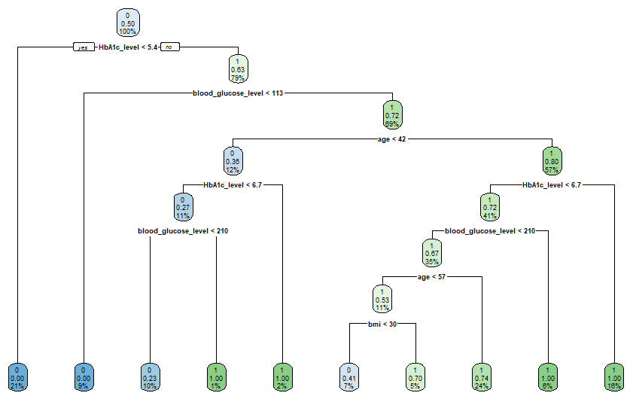Figure 5: Illustration of CART Model

4.2.2 Evaluation of CART Model
The CART Model illustrated is a binary tree, which makes decision making easy, similar to a flowchart. This model has 10 terminal nodes which makes the model easy to interpret.
It can be observed that the HbA1c level, blood glucose level, age, and BMI play an important role in predicting whether the person has diabetes. The most important variable is the HbA1c levels being the root node, where a value of less than 5.4% would mean that the person most likely does not have diabetes. A value of more than 5.4% would then require further investigation, which is the blood glucose levels and whether it is above or below 113 mg/dL. Above 113mg/dL would once again require further investigation on age and so on. Interestingly, this model did not take into account whether this person has hypertension or heart disease.
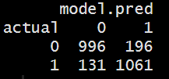
Figure 6: Confusion matrix of CART Model

The model has an accuracy rate of 86.3% (overall error rate of 13.7%). The model also has a 11.6% False Positive rate (predicting having diabetes when in fact, they do not), and a 15.6% False Negative rate (predicting not having diabetes when in fact, they have diabetes).

Based on this CART Model, health providers should focus on the HbA1c levels and blood glucose levels to have a head start on identifying potential undiagnosed diabetes patients.

4.3 Random Forest
Random forest is an ensemble predictive model that constructs multiple decision trees to estimate the value of a target variable based on predictor variables. By aggregating the predictions from many individual trees (e.g. CART) through majority voting for classification or averaging for regression, random forest improves predictive accuracy and reduces the risk of overfitting compared to a single decision tree. This approach is also particularly effective for capturing non-linear relationships and complex interactions within the dataset.

4.3.1 Results from Random Forest Model
To determine which variables were important, two key metrics were employed: Mean Decrease Accuracy and Mean Decrease Gini. The former reflects the reduction in model performance when a variable is removed; a higher value indicates greater importance. The latter measures the average reduction in node impurity contributed by each variable across all trees in the forest, where higher values indicate stronger discriminatory power between diabetic and non-diabetic individuals.
The results show that HbA1c level, blood glucose level, and BMI are the most influential predictors of diabetes, followed by age and hypertension, which also contribute meaningfully to model performance (see Appendix D). This suggests that even when individuals exhibit similar glucose levels, older adults may carry higher diabetes risk, highlighting the importance of incorporating demographic factors such as age alongside biochemical indicators to improve predictive accuracy.

4.3.2 Evaluation of Random Forest Model
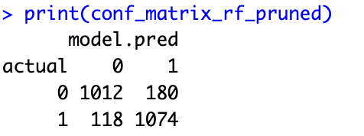
Figure 7: Confusion matrix of Random Forest
Based on Figure 7, the overall accuracy rate is approximately 87.5%. These values suggest that the Pruned Random Forest has a False Positive Rate of 10.4%, False Negative Rate of 14.4%, and an overall Error Rate of 12.5%. The model is doing fairly well, but there is room for improvement, especially in reducing false negatives.

4.4 Model Comparisons
The results of the three models are summarized in Table 3.

Table 3: Model comparisons between Logistic regression, CART and Random forest
 | Logistic Regression | CART | Random Forest | Significance of Metric
Overall Accuracy | 83.7% | 86.3% | 87.5%
False  Positive Rate | 17.2% | 11.6% | 10.6% | Predicting that the person has diabetes when he does not
False  Negative Rate | 15.3% | 15.6% | 14.0% | Predicting that the person does not have diabetes when he does

Out of the accuracy metrics, while a higher overall accuracy is sought for, false negative rate should also be a higher weightage to consider in our case of identifying whether a person could have diabetes, as it is quite detrimental if the model predicts that the person does not have diabetes, when the person in fact has diabetes, which basically means the person may not get the necessary early treatment required.

Based on the table above, the random forest model has the highest overall accuracy with 87.5%, and it also has the lowest false positive rate and lowest false negative rate of the three. So in our case, no matter the metric, the random forest is the more accurate and hence the more appropriate model to be used to predict whether a person has diabetes.

4.5 Clustering
Clustering is an unsupervised learning technique that groups observations into clusters based on similarity across selected features, without requiring a predefined target variable. The resulting clusters reveal underlying patterns or structures in the data, facilitating insights into natural groupings within the dataset.

4.5.1 Results from Clustering Model
In this application, clustering was applied to variables age, BMI, HbA1c, and blood glucose to identify inherent patterns and potential groupings related to diabetes risk.
A K-means clustering algorithm was applied to segment individuals according to these numerical variables. Prior to clustering, the data was scaled to ensure all features contributed equally to the algorithm. The optimal number of clusters was determined using the Elbow Method—the point at which adding more clusters does not improve the model performance significantly. The optimal number of clusters identified was k=3. This value was used for the clustering algorithm and the cluster assignments for each individual were added as a new column in the dataset for further analysis. The results are shown in Figure 8.
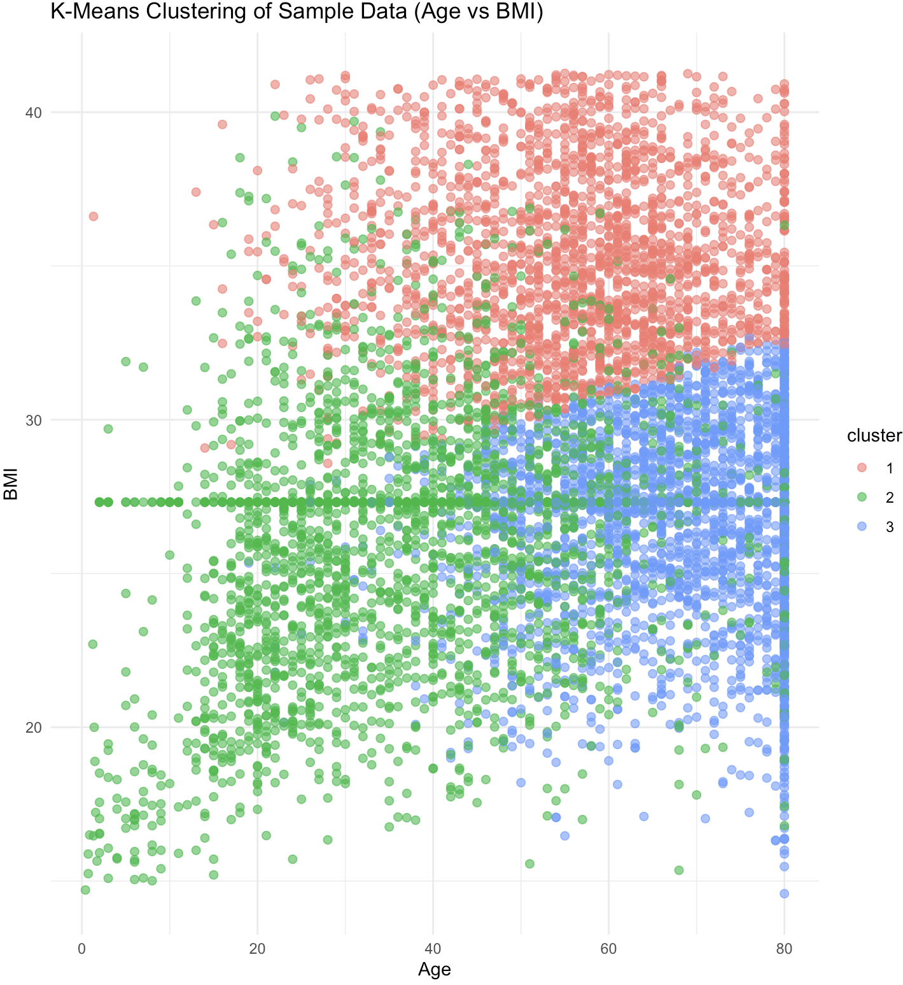
Figure 8: Scatter plot for age against BMI using K-Means Clustering Model

For each cluster, average values of the health metrics were calculated to understand typical characteristics. Examination of diabetes prevalence within clusters revealed that some clusters contained a higher proportion of individuals with diabetes than others. Based on these patterns, the clusters were categorised into two primary risk groups:
- High-risk group: Clusters 1 and 3, characterized by higher BMI and HbA1c levels
- Low-risk group: Clusters 2, characterised by lower BMI and HbA1c levels
These findings highlight distinct subgroups within the population that may correspond to differing diabetes risk profiles, providing a basis for targeted preventive interventions.

4.5.2 Evaluation of Clustering Model
To assess the quality of the clustering results, we compared the assigned clusters with individuals’ actual diabetes status. Based on the cluster characteristics observed earlier, we classified Cluster 1 and Cluster 3 as high-risk groups and therefore diabetic, while Cluster 2 was classified therefore non-diabetic.
Using this assumption, we evaluated how well the clusters aligned with true diabetes status by treating cluster membership as a proxy “prediction.” Accuracy was then computed by comparing the predicted diabetes risk group, based on cluster assignment, with the actual diabetes labels. The result of this analysis is shown in Figure 9.
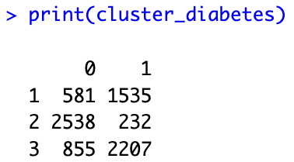
Figure 9: Confusion matrix of the clustering model
Although the clustering approach was useful in identifying groups with differing risk profiles, it does not directly predict diabetes status, given that clustering is an unsupervised method. Additionally, the clustering results could potentially be improved through feature engineering. For example, combining related variables such as BMI and HbA1c into composite indicators may strengthen the separation between clusters and reveal more pronounced patterns relevant to diabetes risk. From a communications perspective, the visualisations produced through the clustering process provided a clear and intuitive depiction of how individuals were grouped based on key health metrics, enabling easy interpretation of the associated risk patterns.

5. Implications

5.1 Model Deployment in Healthcare Setting
Among the models developed, the random forest model was selected due to its strong performance, achieving an overall accuracy of 87.5%, a false-positive rate of 10.6%, and a false-negative rate of 14.0%. These results highlight the strong potential of the model as a preventive detection for diabetes.
To enable practical application of the predictive model, integration with the Singapore health ecosystem will be crucial. Deploying the random forest model in a non-technical operational setting will require simplification of its outputs and clear communication of how patient data contribute to individual risk assessments. Beyond just assigning broad risk categories (e.g. low, medium, high), the model will be able to generate a personalized diabetes risk score and indicate which risk factor resulted in the scoring to support precise and patient-specific intervention. ​​Operationalising this model would enable healthcare providers to identify high-risk patients more efficiently and initiate timely interventions, ultimately contributing to improved chronic disease management and reduced diabetes burden. To ensure sustained performance and relevance, the model should be periodically retrained using relevant population health data and monitored through a structured risk-governance framework.
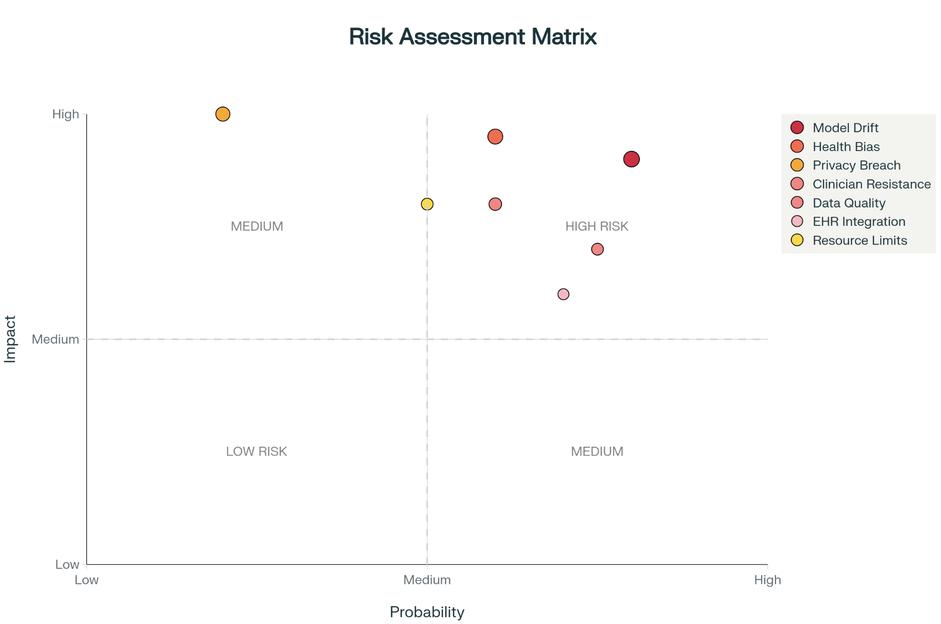
Figure 10: Risk Assessment Matrix

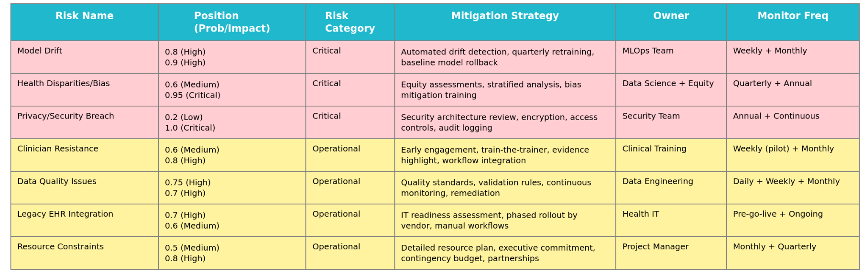
Figure 11: Risk Assessment Matrix Reference Table

5.2 Current State Assessment: Strengths & Acknowledged Limitations
The strengths of our model are as follows, the model has an 87.5% overall accuracy which outperforms existing screening tools that are usually around 60% value. To add on, our model has a 14.0% false negative rate which means that we miss fewer cases of diabetes compared to other models. This is critical for prevention and early detection. Feature engineering identifies clinically meaningful patterns in HbA1c & glucose. Random Forest captures complex interactions that are far superior to linear models.
Despite the positives mentioned earlier, our model may not be the most accurate as of now due to the limited data quality and data availability, so our model has to be constantly trained over time to improve its accuracy and reliability. One of the 6 key limitations is the dataset size, we use data that only represents 1% of the Singapore population. Secondly, our data source is not specific to Singapore. Thirdly, we also did not have full access to all clinical data and might have missed important variables. Fourthly, we also did not get external validation as there was no test on independent data. Lastly there may be bias as the data set is unvalidated across demographic groups and the data is untested in real practice.
Finally, regarding the privacy of such data, there needs to be strict adherence to data protection regulations to uphold the privacy of such sensitive health information.

5.3 Proposed Research Validation Roadmap
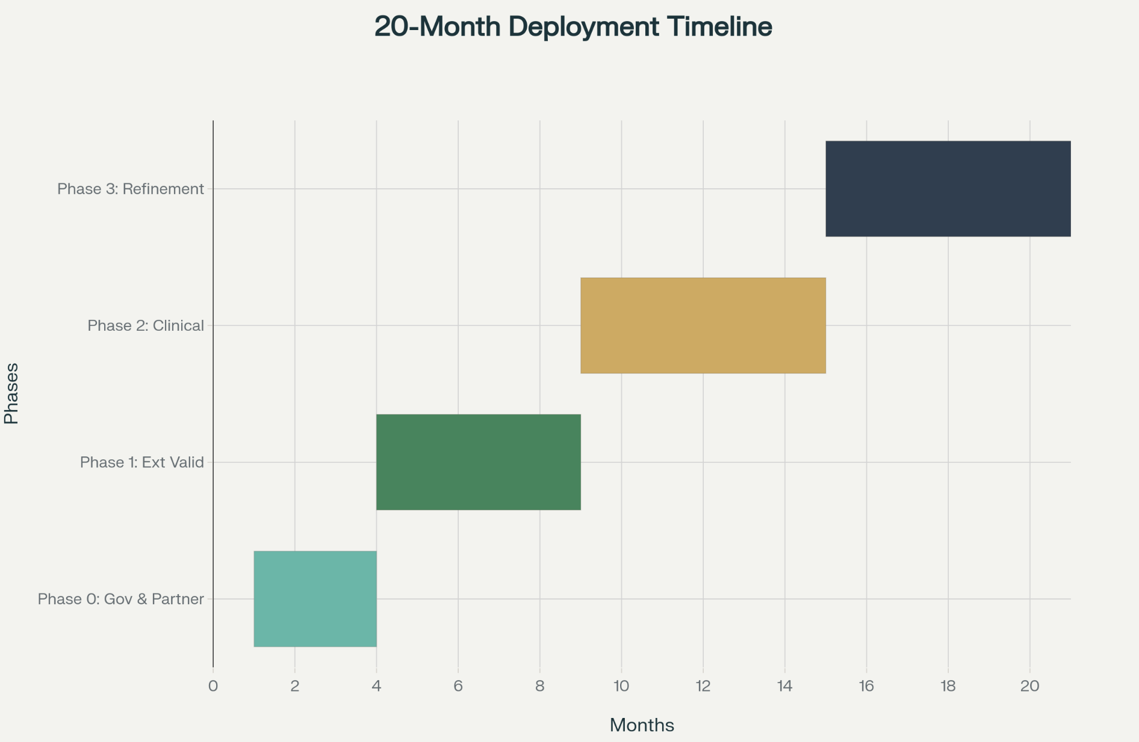
Figure 12: Proposed project implementation timeline
Figure 11 illustrates the proposed project timeline based on the promising results of our model. To ensure a successful deployment of the diabetes prediction mode, a structured multi-phased plan is proposed.
Phase 0: Governance & Partnership Establishment
This phase establishes the institutional and regulatory foundation necessary for model deployment. Given that our predictive model will require access to additional patient data, this stage prioritizes compliance, stakeholder coordination, and ethical approval before any real-world testing begins. Key activities include securing data-use agreements with the Ministry of Health (MOH) and obtaining ethics clearance from the Institutional Review Board (IRB).
Phase 1: External Validation using Population-Level data
This phase focuses on validating model performance using real local healthcare data and includes the following activities:
- Data Acquisition & Preparation
  - Controlled acquisition of 50,000–100,000 de-identified patient records across polyclinics, private GPs, and hospital outpatient settings
  - Setting inclusion criteria (e.g. adults ≥18 years with available HbA1c and glucose values)
- Model Evaluation
  - Validation of accuracy (target ≥85%), ROC-AUC, sensitivity, specificity, and false-positive/negative rates
  - Calibration curve analysis to evaluate risk-score reliability
  - Benchmarking against existing national diabetes screening tools
- Interpretation and Remediation
- If performance meets criteria, results support model readiness for clinical testing
- If degradation or bias is observed, refine the model through feature augmentation or retraining
- Reporting
  - Preparation of a validation assessment report to support transparency, reproducibility, and decision-making to the relevant authorities
Phase 2: Real-world Clinical Validation
Phase 2 moves from controlled validation to practical evaluation in 3 to 5 primary-care sites, including both public polyclinics and private practices, representing diverse demographics and EHR systems. The predictive model will initially run in “silent mode,” generating risk scores that are not visible to clinicians. Patient outcomes will be tracked over 2 to 3 months to assess whether high-risk predictions align with actual diabetes onset, providing real-world evidence of model performance amid common data inconsistencies.
Following silent validation, the model interface will be made visible to clinicians. Training sessions will be conducted, and adoption, override rates, and decision-time impacts will be measured. Semi-structured interviews with 10–15 clinicians will capture qualitative insights into trust, interpretability, and workflow integration, forming a mixed-methods usability assessment.
In parallel, patient surveys (n ≥ 200) will evaluate comprehension, trust, behavioral motivation, and willingness to use the system repeatedly. This dual assessment ensures the model is both operationally effective and ethically aligned with patient engagement principles.
Phase 3: Model Refinement and Final Validation
In Phase 3, findings from earlier stages will be synthesized to identify any remaining gaps in predictive accuracy or adoption. Cross-site and subgroup analyses will guide targeted model improvements, including reweighting, adding covariates, or stratified retraining. Enhanced models will be validated on independent datasets to ensure robust performance without overfitting. Validated results will be disseminated through peer-reviewed publications and policy briefs to inform evidence-based national integration.

5.4 Conclusion
The project has, in essence, shown the various ways data analytics and machine learning could improve early detection and prevention of diabetes in Singapore. We were able to find the crucial predictors of diabetes, namely HbA1c level, blood glucose level, BMI, and age, applying models such as Logistic Regression, CART, Random Forest, and Clustering, and came up with a full model with an accuracy of 87.5%. With better predictive insights, healthcare professionals will be able to better target high-risk groups and intervene earlier.
However, it is worth mentioning that our current findings are based on a limited dataset that represents only a small proportion of the population and that the data is from outside of Singapore. This suggests that our model requires further validation with a dataset that is larger and has more representation. Without taking this step, our conclusions about practical deployment would be premature. But that does not discredit our work and in fact our work serves as a strong foundation that serves to encourage a strong collaboration with MOH and SingHealth. Thus moving forward, the focus will be on acquiring larger and more representative dataset and also on clinical testing to build trust and have reliability across diverse populations.
All in all, the model is promising in terms of accuracy and provides valuable insights but there is a need for refinement by working more alongside key institutions such as MOH and SingHealth. This evidence driven approach will ensure the effectiveness of our predictive tool and also ultimately support Singapore’s goal of reducing national diabetes.

Appendices

Appendix A: Summary of Dataset
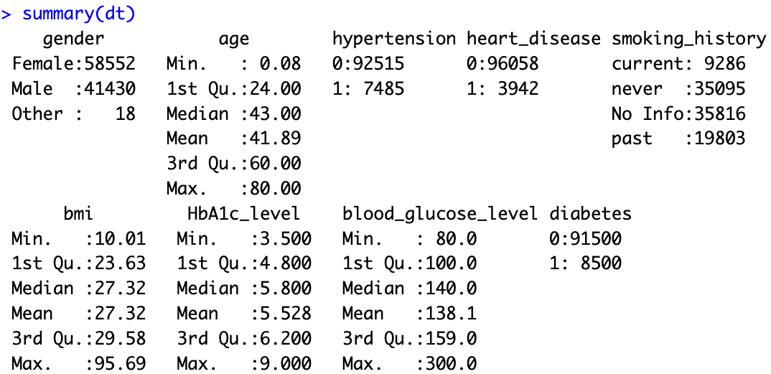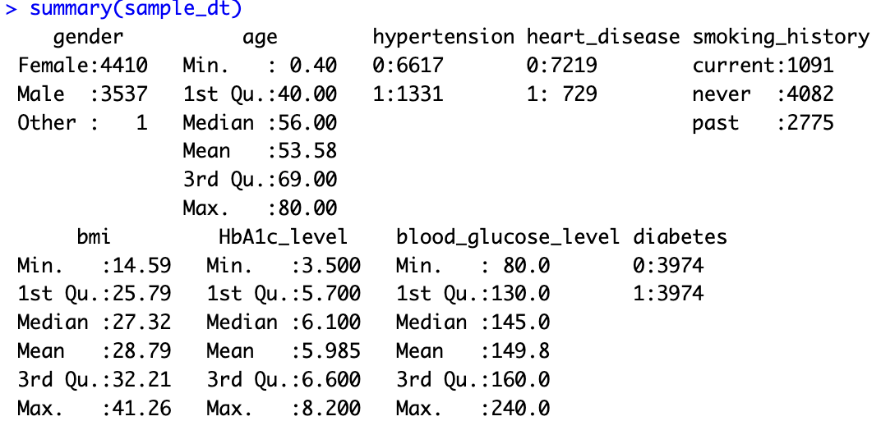

Appendix B: GVIF Values of Variables

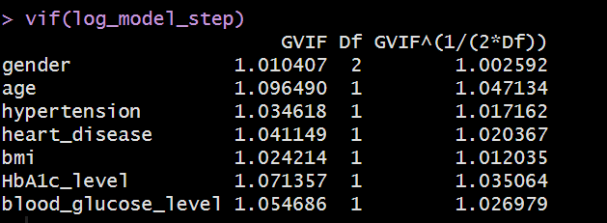

Appendix C: Complexity Parameter for CART model
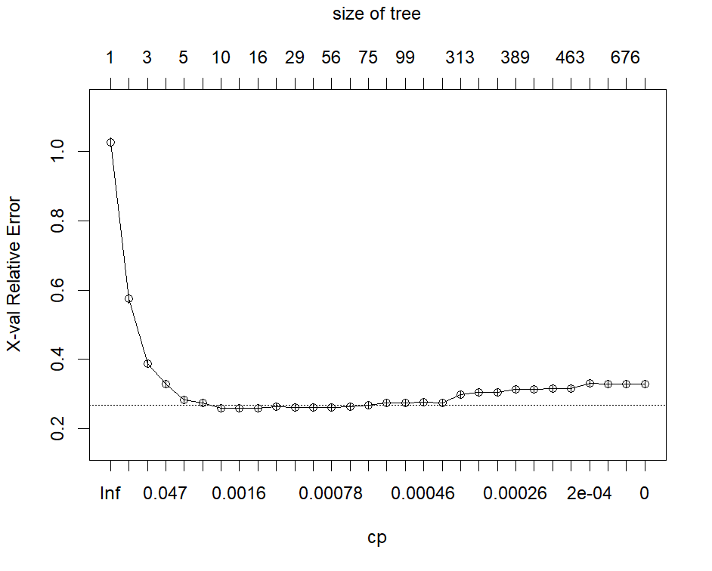

Appendix D: Feature Importance for Random Forest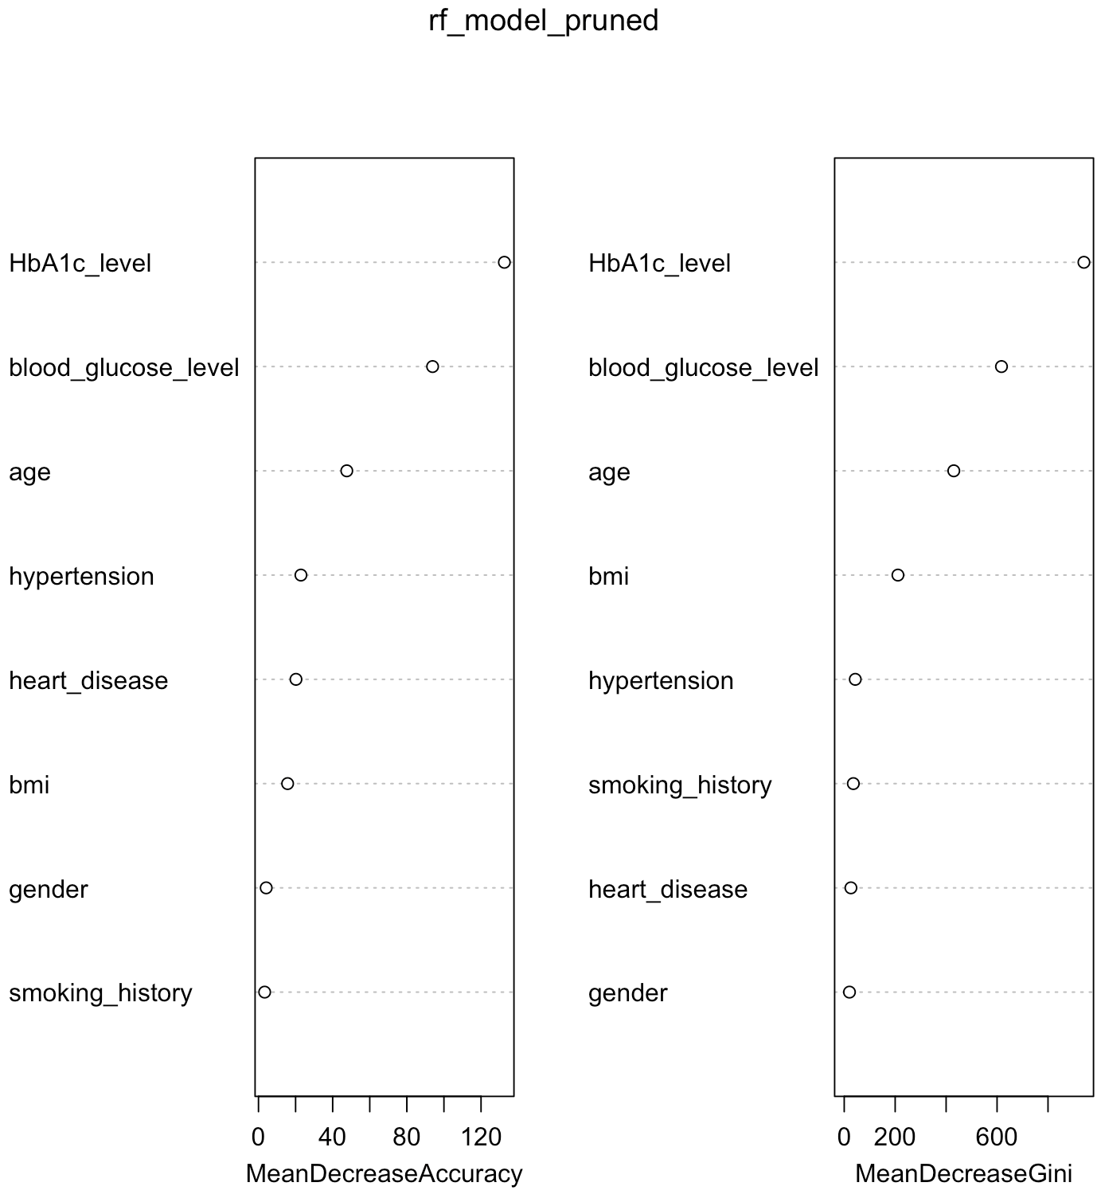

References
Ministry of Health Singapore. (2017). Diabetes risk assessment tool. https://www.moh.gov.sg
Ministry of Health Singapore. (2022). The war on diabetes: Progress and challenges. https://www.moh.gov.sg
Ministry of Health Singapore. (2023). Healthier SG: The future of preventive care. https://www.moh.gov.sg
Ow Yong, C., & Koe, S. (2021). The rise of diabetes in Singapore: Trends and projections. Health Policy and Systems, 19(4), 301–309. https://health-policy-systems.biomedcentral.com/articles/10.1186/s12961-021-00716-1
Smith, J., Brown, A., & Green, L. (2020). Predictive models for diabetes risk in populations: A review of machine learning approaches. PubMed. https://pubmed.ncbi.nlm.nih.gov
Ting, H., Zhang, M., & Lin, X. (2019). Challenges of implementing machine learning in healthcare: The case of diabetes prediction. PubMed. https://pubmed.ncbi.nlm.nih.gov

